**SOLID-STATE CIRCUIT BREAKERS**

Student’s Name

Tutor’s Name

Course Code and Name

Institutional Affiliation

Submission Date

# **Abstract**

Solid-State Circuit Breakers (SSCBs) are reported as having emerged as a component of transformative and innovative technology in the field of power electronics as it provides advanced features and superior benefits compared to conventional circuit breakers. Owing to the growing demand for more reliable, effective, and efficient power distribution systems, SSCBs have increasingly become the focal point of modern development and research. Thus, this report principally tailors its focus on investigating the advancements and implementation of SSCBs in the modern power systems, particularly focusing on the deliberations of exiting literature coupled with suggestions for future improvement in relation to its design, simulation, risks, and demonstration.

*Keywords*: Solid-State Circuit Breakers, Power Distribution Systems

**Table of Content**

**Abstract 2**

**Introduction 4**

**Literature Review 5**

**Design 7**

**Simulation 9**

**Investigation of Risks 14**

**Conclusions and Recommendations 15**

**Demonstration 16**

**References 18**

# **Introduction**

Solid-State Circuit Breakers (SSCBs) are a representation of the transformative technology within the power electronics context. SCBs offer advantageous services over the traditionally used electromechanical circuit breakers as they provide higher reliabilities, faster response times, and enhanced controllability thresholds. There is increasing demand for reliable and efficient power distribution systems that has triggered the need for developing advanced devices for circuit protecting owing to the acknowledgment that the conventional circuit breakers are limited in terms of performance, speed, and size (Xu et al., 2021). Owing to the increased necessity for devices that can ensure compact protection in power systems, the situation has instigated the need to explore novel technological advancements in power electronics. SSCBs is one of the advancements acting as the transformative innovation intended to replace traditional circuit breakers with much effective counterparts steered on revolutionizing circuit protection through swift detection and response to faults to provide unmatched control and precision towards safeguarding electrical networks. Thus, SSCBs have emerged as the promising solutions for not only addressing the prevailing limitations linked with conventional circuit breakers but also guaranteeing precise control over any potential fault clearing operations (Ugalde-Loo et al., 2022). In this report, the primary aim is focused on discussing the advancements and implementation of SSCBs in the modern power systems in regard to their design and simulation with an extended consideration of relevant literature, associated risks, and applications. The report, therefore, delves into providing a comprehensive understanding concerning the application of SSCBs in power electronics ranging from the related theoretical concepts to their practical implementations while providing recommendations aligned to their use for further development. Thus, in line with this focus, the objectives to be achieved are as stated below.

* To explore the principles that govern the operation of SSCBs entailing their fault detection algorithms and semiconductor switching mechanisms.
* To assess the key parameters and performance metrics that influence the safety, efficiency, and reliability of SSCBs in their diverse operating conditions.
* To examine the various applications of SSCBs in different sectors ranging from electric vehicle charging and renewable energy integration to smart grid deployment and industrial automation.
* To evaluate the cost-effectiveness and economic implications associated with the deployment of SSCBs considering elements such as lifecycle expenses, installation, and maintenance in comparison to conventional technologies on circuit protection.
* To investigate the regulatory considerations and technical challenges or risks that hinder the widespread adoption of SSCBs and propose suitable strategies to address the existing barriers in market penetration.
* To discover the emerging trends in connection with future trends relating to SSCBs technology including advancements in system-level integration, packaging techniques, and semi-conductor materials for enhanced functionality and performance.

# **Literature Review**

As informed by Shen et al. (2015), the concept of SSCBs is reported to having originated from the specific need of enhancing the performance and efficiency of power distribution systems. There has been the utilization of power electronic devices, such as SIMULINK, MATLAB, GTOs (Gate Turn-Off Thyristors) and IGBTs (Insulated Gate Bipolar Transitors), in developing solid-state alternatives to traditional (conventional) circuit breakers. The view of Shen et al. (2015) is expounded by Gu et al. (2017), who introduced the concept of fault-tolerant SSCB whose architecture embody the capability to swiftly isolate faulty sections while ensuring the maintenance of system integrity. In an interrelated perspective, the work of Rodrigues et al. (2020) reported on the topologies aligned to control strategies channelled towards optimizing SSCBs performance by proposing hybrid designs that combine transistors and thyristors to foster the achievement of high capabilities for fault current interruptions and fast response times. Moreover, Song et al. (2021) posited that there have been advancements in simulations tools such as MATLAB, EMTDC, and PSCAD that have consequently facilitated the performance evaluation and virtual prototyping of SSCBs when operating under different conditions. As a result, Harris and Kennedy (2021) agreed with these deliberations by arguing that SSCBs have played a significant role within the electrical systems through improving their protection from short circuits and overflow currents. The researchers, Harris and Kennedy, provided the awareness that traditional circuit breakers have been embroiled in limitations such as mechanical wear and slow response time due to the consideration that they utilize mechanisms of magnetic and thermal trips in interrupting current flow, a position supported by Song et al. (2021) in relation to circuit protection.

Song and colleagues deliberated that SSCBs have fueled a paradigm shift in the circuit protection technology by leveraging various power electronic devices using transistors and thyristors that promote precise current interruptions and rapid switching capabilities. As a result, Kheirollahi et al. (2021) reported that SSCBs are characterized with aspects of versatilities. These aspects make them effective and suitable to have a wide range of applications in automotive, energy, and smart grid systems owing to their enhanced safety, reduced maintenance requirements, and increased compatibilities with the modern power systems, a view expounded on by Lumen et al. (2020). Lumen et al. (2020) highlighted the advantages associated with SSCBs over conventional circuit breakers in the realms of their precision, response, and maintenance with reference to ensuring normal current flow and interrupting overflow during faulty events. In this context, Lumen et al. (2020) ascertained the feasibilities of SSCBs in high and medium voltage applications in line with ensuring proper fault detection and thermal management algorithms to support and sustain reliable operations, a proposition that Kheirollahi et al. (2021) strengthened. Kheirollahi et al. (2021) postulated that the advancements in semiconductor technologies have triggered the development of SSCBs that provide superior performance characteristics over the ones operating on conventional models in enhancing circuit operation and protection.

# **Design**

Typically, as suggested by Xi et al. (2022), the design of SSCB entails selection suitable power electronic elements and their configuration into appropriate topologies by designing control algorithms and integrating effective protection features. The electrical components are arranged in parallel and series configurations in connection with switches controlled by gate drivers for handling currents and voltages. As a result, underlying the architecture of SSCB design, as depicted in the diagram 1 below, to facilitate its operation, is usually the utilization of semiconductor devices, control unit, protection algorithms, gate driver circuitry, current and voltage sensors, heat dispensation system, and communication interface.

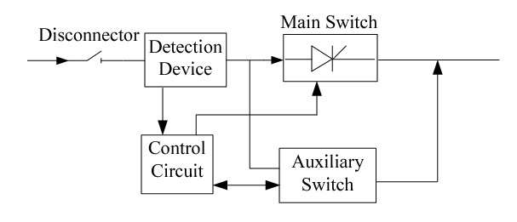

Diagram 1: Architecture of SSCB

In the operation of the SSCB system, it uses power semiconductor devices such as MOSFETS (Metal Oxide Semiconductor Field-Effect Transistors), IGBTS (Insulated Gate Bipolar Transistors) or thyristors that can be rapidly controlled to help in handling high currents and voltages. SSCB uses control units to monitor various electrical parameters such as frequencies and voltages in the circuit, and subsequently process the collected information to steer decision-making in regard to the circuit breaker operation (Purgat et al., 2021). Protection algorithms are used in the SSCB to detect any default condition in the circuit such as overvoltage and short circuit situations. Date driver circuitry are used to control the switching of the semiconductor devices by receiving signals from the control units and providing necessary current and voltage pulses to rapidly turn the devices either on or off. Current and voltage sensors are used in monitoring the energy flow in the circuit and consequently providing feedback to the control units to enable the accurate detection of any abnormal conditions and trigger the circuit breaker as necessary (Yu et al., 2020). Communication interfaces such as Profibus, Modbus, or Ethernet as used in the SSCB system to covet information to the monitoring or external control devices to allow for remote supervision of circuit operation( Tracy & Sekhar, 2020). With the interconnectedness of these components, the systems is allowed to dissipate heat so that it handles high levels of power and generate heat during its operation. Adequate regulation of heat entail the use of fans and heat sinks in maintaining the standard temperatures of the semiconductor devices within the set safe limits. Through heat dissipation, redundancy and fault tolerance is enhanced to ensure the reliability of the SSCBs by using self-diagnostic capabilities, duplicate components, and fail-safe mechanisms that help in preventing catastrophic failures. The enhanced fault and redundancy tolerance increases the modularity and scalability of the SSCBs to allow for their easy integration into different power distribution systems linked with improved adaptation to various current and voltage ratings (Harris & Kennedy, 2021). The design of SSCB system is at all times guided by the primary principle of seeking to ensue that it promotes and maintains the aspects of protection. Hence, the design of SSCBs based on its architectural model that depict its operational framework in monitoring and controlling power distribution to provide safety.

# **Simulation**

The simulation of SSCBs is anchored on the practicality of applying the system into a real-word monitoring and control environment in an electrical setting to regulate circuit currents and voltages. In this regard, simulation serves an important role in validating the SSCB design and evaluating its performance in actuating responses to transient phenomena such as over-voltages and short-circuit faults towards assessing power stability and quality (Kheirollahi et al., 2021). Thus, through simulation, the effectiveness of the SSCB system can be examined in diverse fault scenarios that include over-currents and short circuits. Various parameters such as interruption time, detection time, fault clearance are calculated to validate the efficiency of the design in relation to its monitoring and control strategies in power distribution. These strategies are vital to ensure that there is proper protection and operation of the SSCB in regulating the elements of temperature, current, and voltage through an intelligent monitoring and control algorithm that has the potential of detecting fault condition to subsequently trigger a rapidly necessary circuit interruption (Hughes & Weise, 2021). According to Hughes and Weise (2021). Simulation of SCB system is often embedded in using various software, the most common ones being MATLAB and SIMULINK, in evaluating the performance of the system in terms of its control and monitoring strategies under different conditions of operation.

Since simulation is based on practical applicability, using a case scenario of building SSCB system in an electric system to produce simulated results, a GUI-based feature in the graphic user interface of SIMULINK software in an electrical power distribution was applied. A 22-kV feeder of power distribution with a load of 200kW, 150 kvar was created having the protection of the SSCB system was situated using a circuit breaker of a thyristor, as shown in figure 1 below.

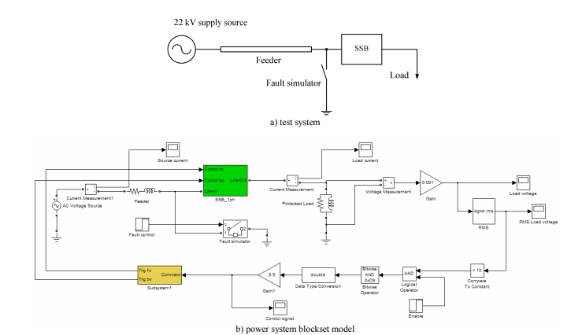

Figure 1: SIMULINK Model of the Test Feeder

Based on the assumption that there is the occurrence of a short-circuit event at t = 0.16s, the test case scenario was performed in a time span of 0.2s. The situation took a whole first cycle to enable the rms attain its actual rms voltage. Upon the first fault occurring at t = 0.16s, the load voltage experienced a sudden drop to the value that is close to zero as shown in figure 2 below, with the rms value for the load voltage presented in figure 3.

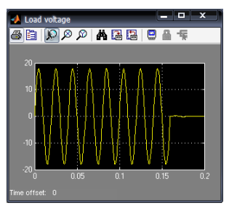

Figure 2: Load Voltage (kV)

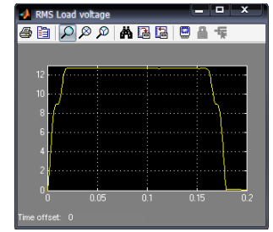

Figure: rms load voltage (kV)

In verifying the effectiveness and efficiency of SSCB in interrupting the fault current, the currents that had been supplied by the given source and drawn by the load were recorded. Figure 4 below giving information of the source current, and this figure intentionally indicated the current during the fault event, depicting the current drawn by the load at the normal loading condition.

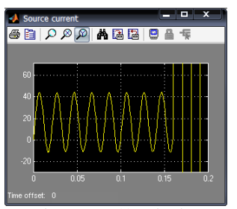

Figure 4: Source Current

The load current is shown in figure 5 below, and it indicated the DC component during its operation under normal load conditions. The maximum positive peak current is slightly above 40A, depicting that the SSCB successfully interrupted the detected fault current, with zeroing load current supporting this reason. Figure 6 additionally illustrated the firing command showing the transition status of the SSCB from turn-on to complete turn-off following the interruption of the fault current, considering that the during the fault the load current has no DC component.

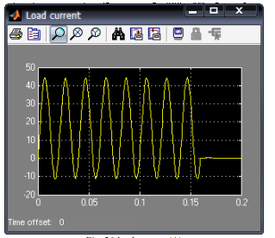

Figure 5: Load Current

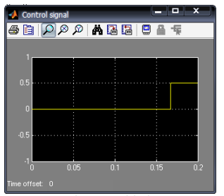

Figure: Command Signal

Based on the above simulated results, it is evident that SSCBs are effective and efficient in not only detecting but also interrupting fault current. The simulation provided a valid evidence on the applicability of SSCB, by using GUI-based environment of SIMULINK, to test against a fault condition in an electric power distribution system. The scenario supports the effectiveness and efficiency of SSCBs as appropriate sensing techniques in monitoring and controlling current and voltage by simultaneously interrupting fault to enhance protection and safety of electrical systems.

# **Investigation of Risks**

Despite the advantages that SSCBs provide over the conventional circuit breakers through ensuring increased reliability realized by higher precision and faster response, as with the case of any technology, SSCBs also come their unique sets of challenges. Hence, with the associated benefits withstanding, SSCBs consequentially pose severe risks warranting consideration. As argued by Zhao et al. (2022), vulnerabilities of the semiconductor devices used in SSCBs to conditions of overvoltage and overcurrent is one of the concerns as it risks leading to thermal runaway and device failures. Besides, the reliance of SSCBs on complex control algorithms exposes the risk related to cybersecurity threats and software-related failures. Moreover, integrating SSCBs into the existing electrical systems is pegged on the requirement of thorough testing and validation of compatibility with other power and protection devices. Furthermore, SSCBs is subjected to risks regarding robustness and reliability that arise due to such factors as thermal stress, electromagnetic interference, and component aging that severely impact on their long-term performance. SSCBs come with having to incur higher upfront costs compared to the conventional ones (Zhao et al. 2022). However, Prigmore and Ehlers (2021) elucidate that any failure in adequately addressing these risks present the adverse outcomes witnessed through equipment damages, system downtime, and grid reliability compromise. Prigmore and Ehlers (2021) thus advocates for risks associated with the use of SSCBs to be comprehensively solved. Since safety is undeniably a paramount condition in such electrical systems as SSCBs, it is compulsory for these risks to be addressed. Compliance with testing protocols and component selection is also crucial in preventing premature failures. Meeting the established regulatory standards such as IEC 62271 and IEEE C37.100 provide measures and guidelines that help to ensure the reliability and safety of SSCBs in their various industrial applications. It is necessary to balance the cost-benefits of SSCBs with their respective performance to facilitate their widespread adoption. Seamless integration with legacy technological infrastructure to ensure adherence to industry standards is vital in preventing compatibility issues and guarantee authentication and encryption of SSCBs to prevent intrusion (Prigmore & Ehlers, 2021). As a result, by addressing the potential hazards such as insulation failures, arc flash, overvoltage, and system infiltration during the circuit brake design and deployment, this is crucial in ensuring the system is shielded against adverse risks.

# **Conclusions and Recommendations**

It is doubtless that SSCBs represent a desirably promising technological advancement in power electronics with an associated significant potential of revolutionizing the protection of the electrical networks. SSCBs thus offer crucial improvements in the efficiency and reliability of power distribution systems. Guided by this understanding, it is justifiable that extensive research on design optimization and simulation-based validation can provide a good ground to enable SSCBs record higher performance in comparison to the traditional circuit breakers in terms of controllability, reliability, and speed. However, it is compulsory to address the issues related to robustness, reliability, compatibility, safety so that the full potential of SSCBs can be realized. In this regard, further optimization of the associated control algorithms are necessary to enhance fault isolation and detection. Integration of the advanced features of protection such as self-healing and arc quenching capabilities to be supported. Standardization of the specifications of SSCBs is further crucial in ensuring compatibility and interoperability. Continued advancements are additionally important to improve the device efficiencies and reliabilities of the semiconductor technology applied in SSCBs. Hence, it is of an imperative requirement for the industry stakeholders and researchers in the field of power electronics to foster a collaboration aimed at enhancing the mitigation of existing risks through standards development and rigorous testing that support continuous improvement of SSCB associated technologies. As a result, it is necessary for future research to tailor their efforts on the enhancement of reliability and optimization of control strategies in SSCBs through advanced packaging techniques and application materials.

# **Demonstration**

A demonstration of the SSCB prototype, as posited by Rodrigues et al. (2020), can be carried out in showcasing the characteristics of its performance in a controlled industrial environment. The demonstration entails real-time operations that show fault interruption and detection. It also comprise measuring key parameters including transient response and fault clearing time. It further constitutes comparing the system with traditional circuit breakers under similar operation conditions. It finally encompasses providing a discussion of the potential benefits and applications of SSCBs in practical scenarios (Rodrigues et al., 2020). Therefore, the demonstration of SSCBs is presented by the portrayal of its performance under various conditions pivoted on an experimental setup that includes monitoring instruments, power circuitry, and test bench that simulates real-world scenarios of electrical connections. The performance evaluation of SSCB prototype is guided by the fault conditions such as over-currents and short circuits in association with its response in terms of system recovery, interruption time, and fault detection. The demonstration is crucial as it highlights the inherent effectiveness that SSCBs provides to ensure reliable and rapid circuit protection. It also depicts fault clearing capabilities pegged on robust performance under varied load conditions that provide tangible evidence on the benefits it embodies to the stakeholders (Ludin et al., 2021). Demonstration additionally facilitates real-time monitoring of different key parameters such as temperature, voltage, and current, thus highlighting the effectiveness and reliability of SCBs in the context of practical applications. More importantly, by organizing industry forums, seminars, and workshops, the demonstration is vital in engaging key stakeholders such as regulatory authorities, equipment manufacturers, and power utilities helpful in promoting awareness that can facilitate adoption (Xi et al., 2020). Better still, as explained by Xi et al. (2020), the demonstration allows for soliciting insights and feedbacks that can inform further enhancements and refinements in the design and simulation of SSCBs to foster their deployment within the settings of real-world industrial applications.

# **References**

Gu, C., Wheeler, P., Castellazzi, A., Watson, A. J., & Effah, F. (2017). Semiconductor devices in solid-state/hybrid circuit breakers: Current Status and Future Trends. *Energies*, *10*(4), 495.

Harris, M., & Kennedy, R. (2021). Advances in solid-state circuit breakers. In *2021 IEEE IAS Petroleum and Chemical Industry Technical Conference (PCIC)* (pp. 127-134). IEEE.

Hughes, M., & Weise, N. (2021). Solid-state circuit breaker component simulation. In *IECON 2021–47th Annual Conference of the IEEE Industrial Electronics Society* (pp. 1-6). IEEE.

Kheirollahi, R., Zhang, H., Zhao, S., & Lu, F. (2021). A dc solid-state circuit breaker based on transient current commutation. *IEEE Journal of Emerging and Selected Topics in Power Electronics*, *10*(4), 4614-4625.

Kheirollahi, R., Zhao, S., & Lu, F. (2021). Fault current bypass-based LVDC solid-state circuit breakers. *IEEE Transactions on Power Electronics*, *37*(1), 7-13.

Kheirollahi, R., Zhao, S., & Lu, F. (2021). Fault current bypass-based LVDC solid-state circuit breakers. *IEEE Transactions on Power Electronics*, *37*(1), 7-13.

Ludin, G. A., Amin, M. A., Matayoshi, H., Rangarajan, S. S., Hemeida, A. M., Takahashi, H., & Senjyu, T. (2021). Solid-state dc circuit breakers and their comparison in modular multilevel converter based-hvdc transmission system. *Power Electronics,* *10*(10), 1204.

Lumen, S. S., Kannan, R., & Yahaya, N. Z. (2020). DC circuit breaker: A comprehensive review of solid state topologies. In *2020 IEEE International Conference on Power and Energy (PECon)* (pp. 1-6). IEEE.

Prigmore, J., & Ehlers, D. (2021). Solid State Circuit Breakers–Their Technical, Operational and Application Benefits: Copyright Material IEEE Paper No. ESW2021-23. In *2021 IEEE IAS Electrical Safety Workshop (ESW)* (pp. 1-9). IEEE.

Purgat, P., Shah, S., van der Blij, N., Qin, Z., & Bauer, P. (2021). Design criteria of solid‐state circuit breaker for low‐voltage microgrids. *IET Power Electronics*, *14*(7), 1284-1299.

Rodrigues, R., Du, Y., Antoniazzi, A., & Cairoli, P. (2020). A review of solid-state circuit breakers. *IEEE Transactions on Power Electronics*, *36*(1), 364-377.

Shen, Z. J., Miao, Z., & Roshandeh, A. M. (2015). Solid state circuit breakers for DC micrgrids: Current status and future trends. In *2015 IEEE First International Conference on DC Microgrids (ICDCM)* (pp. 228-233). IEEE.

Song, X., Cairoli, P., Du, Y., & Antoniazzi, A. (2021). A review of thyristor based DC solid-state circuit breakers. *IEEE Open Journal of Power Electronics*, *2*, 659-672.

Song, X., Du, Y., & Cairoli, P. (2021). Survey and experimental evaluation of voltage clamping components for solid state circuit breakers. In *2021 IEEE Applied Power Electronics Conference and Exposition (APEC)* (pp. 401-406). IEEE.

Tracy, L., & Sekhar, P. K. (2020). Design and testing of a low voltage solid-state circuit breaker for a DC distribution system. *Energies*, *13*(2), 338.

Ugalde-Loo, C. E., Wang, Y., Wang, S., Ming, W., Liang, J., & Li, W. (2022). Review on $ Z $-Source Solid State Circuit Breakers for DC Distribution Networks. *CSEE Journal of Power and Energy Systems*, *9*(1), 15-27.

Xi, J., Pei, X., Niu, L., Feehally, T., Wilson, P., Gu, C., & Zeng, X. (2022). A solid-state circuit breaker for DC system using series and parallel connected IGBTs. *International Journal of Electrical Power & Energy Systems*, *139*, 107996.

Xi, J., Pei, X., Zeng, X., & Niu, L. (2020). Design, modelling, test, and application of a solid-state main breaker for hybrid DC circuit breaker. In *2020 22nd European Conference on Power Electronics and Applications (EPE'20 ECCE Europe)* (pp. 1-10). IEEE.

Xu, X., Chen, W., Liu, C., Sun, R., Li, Z., & Zhang, B. (2021). An efficient and reliable solid-state circuit breaker based on mixture device. *IEEE Transactions on Power Electronics*, *36*(9), 9767-9771.

Yu, J. Y., Kim, J. Y., Song, S. M., Ayubu, Z., & Kim, I. D. (2020). New DC solid-state circuit breaker with natural charging operation. *IEEE Transactions on Industrial Electronics*, *68*(11), 10360-10368.

Zhao, S., Kheirollahi, R., Wang, Y., Zhang, H., & Lu, F. (2022). Investigation of limitations in passive voltage clamping-based solid-state DC circuit breakers. *IEEE Open Journal of Power Electronics*, *3*, 209-221.